Patient Name: _______________________________________________________ Date of Birth: _______________________
Referring Physician: ___________________________________________________
Greatest area of pain? ________________________________________________________________________________________
When did it start? __________________________________
Have you been to another pain clinic?
____No
____Yes Physician(s)__________________________________________

Draw your area of pain on the diagram below:
Rate your pain on a scale of 0 to 10:
Today: _________
At its most severe: _________
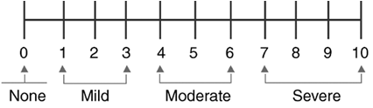
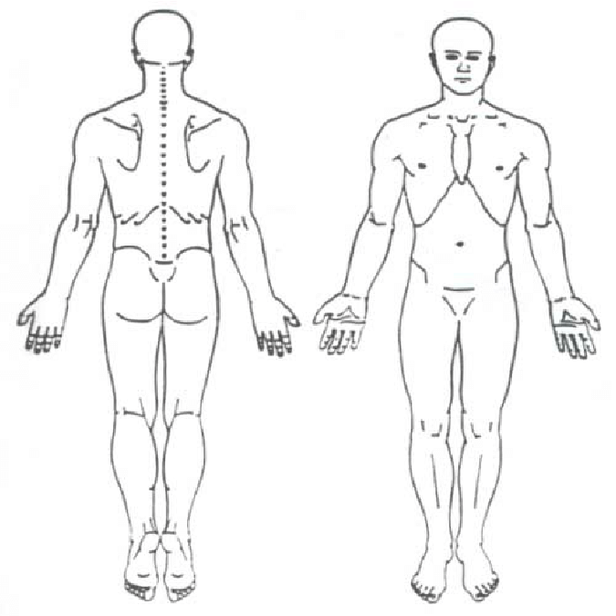

How do you describe your pain?

☐ Aching ☐ Numbness ☐ Stinging ☐ Superficial
☐ Burning ☐ Sharp ☐ Throbbing ☐ Deep
☐ Dull ☐ Shooting ☐ Tightness
☐ Electric-like ☐ Stabbing ☐ Cramping

Which statement best describes your pain:
☐ It is constant ☐ It occurs suddenly ☐ It occurs in the morning
☐ It is intermittent ☐ It occurs gradually ☐ It occurs in the daytime
☐ It occurs occasionally ☐ It occurs at evening
☐ It occurs rarely ☐ It wakes me from sleep

Under what circumstances did your pain begin?
☐ Unknown ☐ Lifting ☐ Sports Injury ☐ Surgical complication
☐ Gradual onset ☐ Over using ☐ Work Injury ☐ Following surgery
☐ Abrupt onset ☐ During Exercise ☐ Motor Vehicle Accident
☐ After a fall ☐ After Exercise ☐ Assault

What makes your pain better?
☐ Nothing helps ☐ Standing ☐ leaning forward ☐ Prescription medication
☐ Heat ☐ Lying down ☐ Stretching ☐ Oral steroids
☐ Ice ☐ Walking ☐ Physical therapy ☐ Steroid injections
☐ Rest ☐ Position change ☐ Chiropractic care ☐ Anti-inflammatories/NSAID
☐ Sitting ☐ while being active ☐ Over the counter medication ☐ Narcotic medication

What makes your pain worse?
☐ Nothing ☐ Lifting ☐ Exercise ☐ Cold Weather
☐ Sitting ☐ Twisting ☐ Flexion ☐ Damp Weather
☐ Standing ☐ Movement ☐ Extension
☐ Walking ☐ Pushing/Pulling ☐ Getting out of bed
☐ Lying down ☐ Gripping ☐ Going from sitting to standing

Do you have any of these symptoms with your pain?

☐ weakness ☐ Tingling ☐ Redness ☐ bruising
☐ numbness ☐ Swelling ☐ Warmth ☐ Bowel or bladder changes

Have you had any of the following treatments for your pain?
☐ Physical Therapy ☐ Did not help ☐ Helped a little ☐ Helped significantly ☐ Helped temporarily
☐ Chiropractic Therapy ☐ Did not help ☐ Helped a little ☐ Helped significantly ☐ Helped temporarily
☐ Epidural Steroid Injection ☐ Did not help ☐ Helped a little ☐ Helped significantly ☐ Helped temporarily
☐ Facet Injection ☐ Did not help ☐ Helped a little ☐ Helped significantly ☐ Helped temporarily
☐ Facet Ablation ☐ Did not help ☐ Helped a little ☐ Helped significantly ☐ Helped temporarily
☐ Sacroiliac Joint Injection ☐ Did not help ☐ Helped a little ☐ Helped significantly ☐ Helped temporarily
☐ Steroid Injection ☐ Did not help ☐ Helped a little ☐ Helped significantly ☐ Helped temporarily
☐ Synvisc/Euflexxa/Hyalgan ☐ Did not help ☐ Helped a little ☐ Helped significantly ☐ Helped temporarily

Other_______________________ ☐ Did not help ☐ Helped a little ☐ Helped significantly ☐ Helped temporarily

Other_______________________ ☐ Did not help ☐ Helped a little ☐ Helped significantly ☐ Helped temporarily

Do you currently have any of the following symptoms?
Constitutional: ☐ Fever ☐ Night sweats ☐ significant weight gain ☐ significant weight loss ☐ Chills
Eyes: ☐ Abrupt vision change ☐ Eye irritation ☐ Eye discharge
Ears/Nose/Mouth: ☐ Ear pain ☐ Frequent nosebleeds ☐ Sore throat ☐ Mouth ulcers
Cardiovascular: ☐ Chest pain ☐ Arm pain on exertion ☐ Shortness of breath when walking ☐ Heart murmur
☐ Ankle swelling
Respiratory: ☐ Cough ☐ Shortness of breath
Gastrointestinal: ☐ Nausea ☐ Vomiting ☐ Constipation ☐ Diarrhea ☐ Dyspepsia (heartburn)
Genitourinary: ☐ Incontinence ☐ Difficulty urinating ☐ Increased frequency ☐ Blood in urine
Skin: ☐ Yellowing of skin ☐ Rashes ☐ Non healing areas ☐ Changes in hair/nails
Neurologic: ☐ Seizures ☐ Dizziness ☐ Tremor
Psychiatric: ☐ Depression ☐ Hallucinations ☐ Suicidal thoughts ☐ Memory loss
Musculoskeletal: ☐ Joint pain/ stiffness ☐ Back/neck pain ☐ Muscle aches ☐ Muscle atrophy
Endocrine: ☐ Fatigue☐ Increased thirst ☐ Abnormal hair loss
Hematologic/Lymphatic: ☐ Swollen glands ☐ Bruising ☐ Excessive bleeding
Allergy/Immunologic: ☐ Hives ☐ Itching ☐ Frequent colds/flu

Please list ALL medical problems and/or history that you may have:
___________________________________________________ _____________________________________________________
___________________________________________________ _____________________________________________________
___________________________________________________ _____________________________________________________
___________________________________________________ _____________________________________________________
Please list ALL surgeries you have undergone:
___________________________________________________ _____________________________________________________
___________________________________________________ _____________________________________________________
___________________________________________________ _____________________________________________________
___________________________________________________ _____________________________________________________
Family History:
Family Member Please list their major health problems
Mother _____________________________________________________________________________________
Father _____________________________________________________________________________________
Brothers _____________________________________________________________________________________
Sisters _____________________________________________________________________________________
Children _____________________________________________________________________________________

Personal History:
Marital Status: Married Single Divorced Widowed
Occupation: __________________________________________________________________________________________________
Are you receiving disability? Yes No Disability diagnosis: _________________________________________
Do you live: Independently Require home assistance Assisted facility
Do you smoke? Yes No Amount ___________________________
Do you drink alcohol? Yes No Amount ___________________________
Do you use illegal drugs? Yes No Amount ___________________________
Have you had a history of: Alcoholism Drug Addiction

Allergies to medications: _______________________________________________________________________________________
Please list any medications you have tried for your pain:
Medication Did it help? Side Effects?
__________________________________________ Yes No ____________________________________
___________________________________________ Yes No ____________________________________
___________________________________________ Yes No ____________________________________
___________________________________________ Yes No ____________________________________
___________________________________________ Yes No ____________________________________
___________________________________________ Yes No ____________________________________
___________________________________________ Yes No ____________________________________
___________________________________________ Yes No ____________________________________
Please list or attach a copy of all medications you are taking now:
Medication Dose How many times a day
____________________________________________________________________________________________________________
____________________________________________________________________________________________________________
________________________________________________________________________________________________________________________________________________________________________________________________________________________________________________________________________________________________________________________________________________________________________________________________________________________________________________________________________________________________________________________________________________________________________________________________________________________________________________________________________________________________________________________________________________________________________________________________________________________________________________________________________________________________________________________________________________________________________________________________________________________________________________________________________________________________________________________________________________________________________________________________________________________________________________________________________________________________________________________________________________

